

**AWS Lab #2**

**By Diego Santos**

**Intro**

We’ll be configuring an Amazon S3 bucket to allow us to host a static website to teach us about website hosting

**Screenshots**

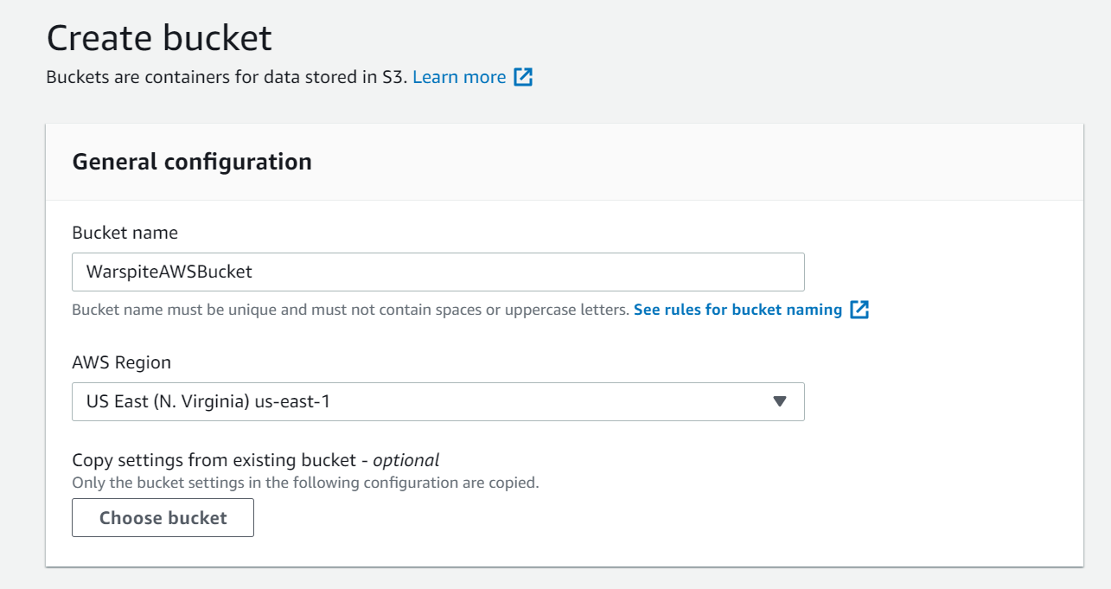

(Creating the initial bucket)

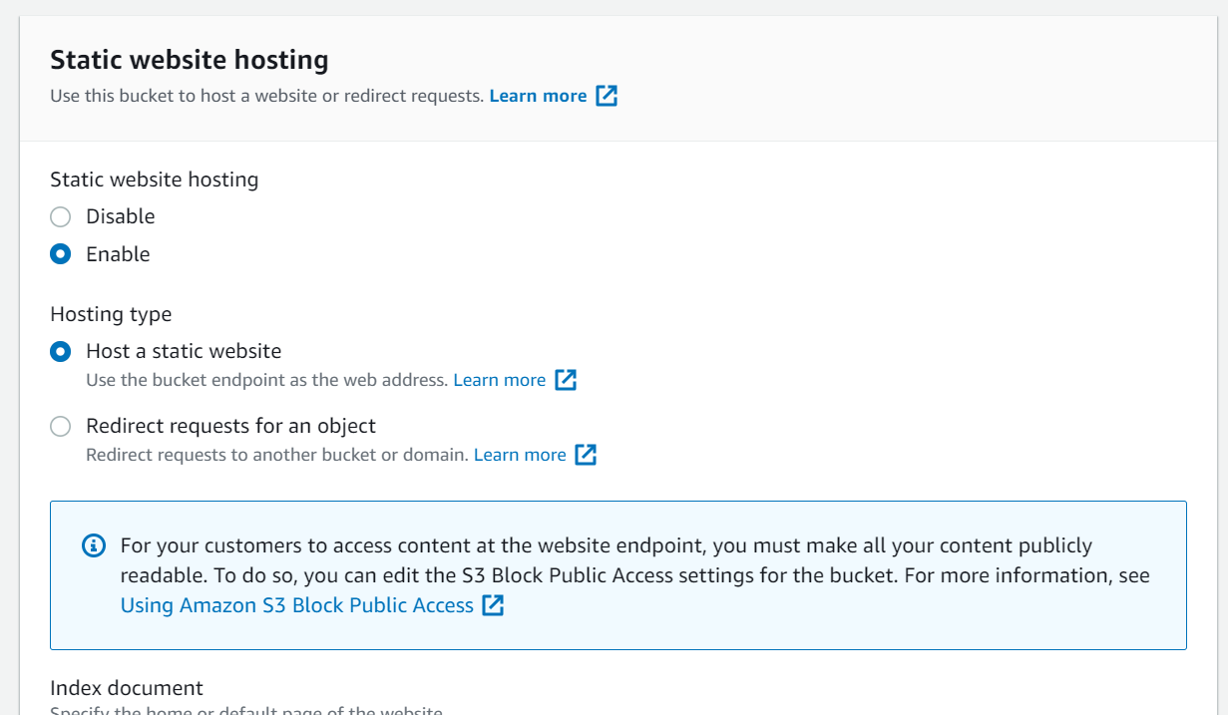

(Enabling static website hosting)

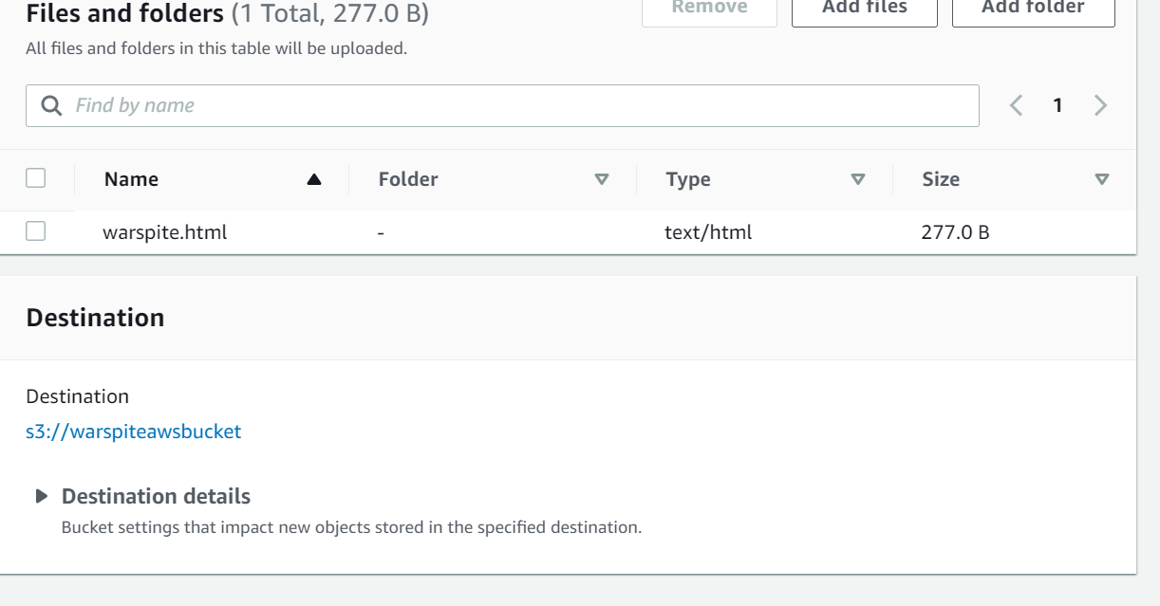

(Adding the website file)

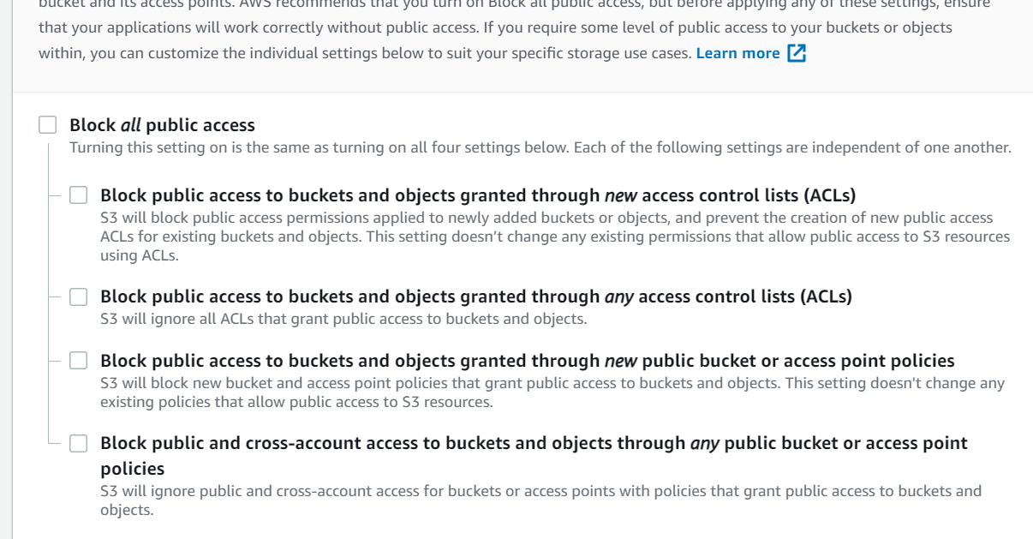

(Unblocking Public Access)

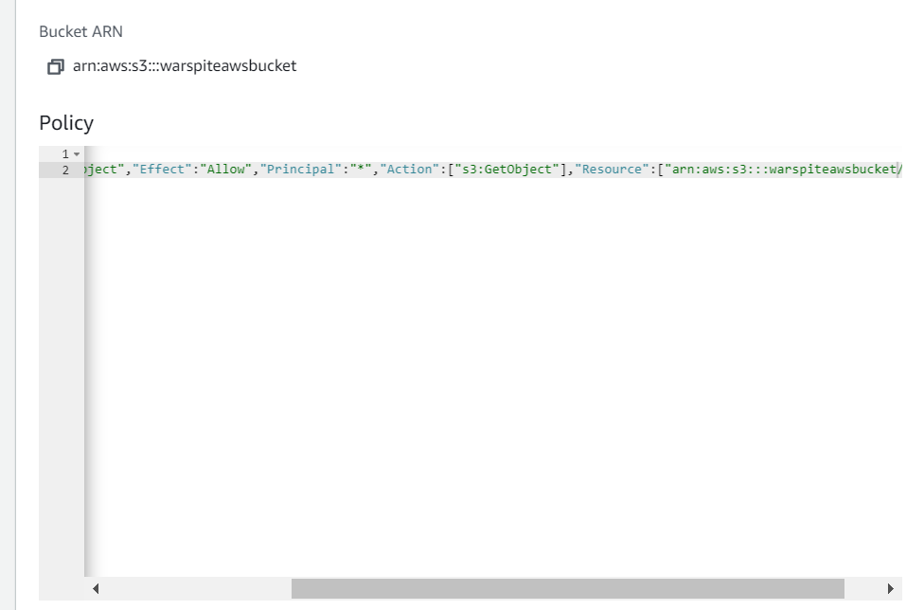

(Adding Bucket Policy)

**Problems**

I experienced no problems when completing this lab